ENGR-1100 IEA

Maple Project #1

Directions: Complete the following problems using Maple

- Perform the following operations on the matrix shown below:
  - Find the inverse
  - Find the determinant
A = 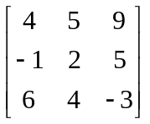

- Solve the following set of equations using Gauss-Jordan Elimination
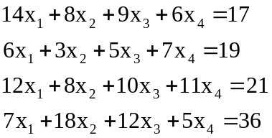

- Solve the following set of equations using the solve command.
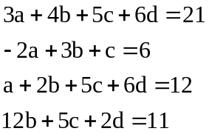

4. Based on the vectors given below:
a. Find the angles (in degrees) between all three vectors
b. Find a collinear unit vector for each vector
c. Find the component of V₁ along the direction of V₂
 